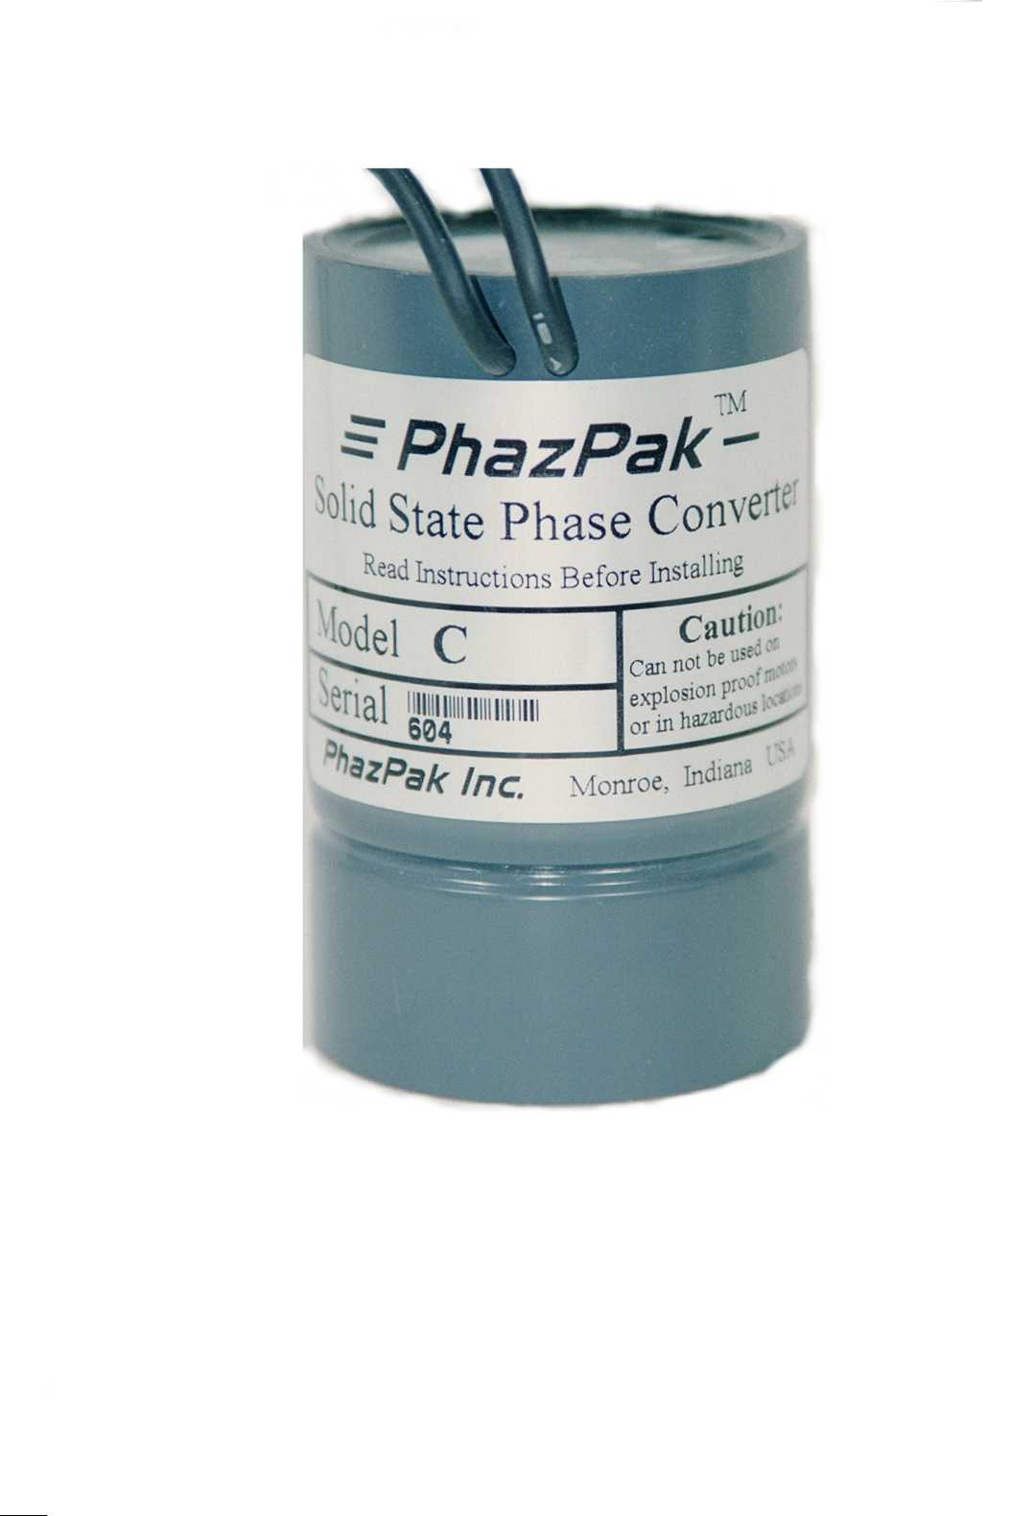
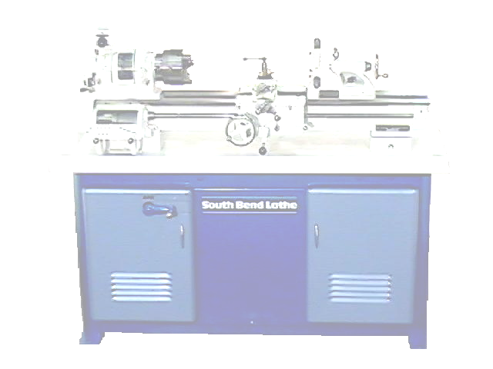
PhazPak has totally simplified the process of converting your three phase motors to single phase. With just two lead wires to connect to your motor, it just can’t get any easier. Other make static type converters use mechanical relays in their units, commonly called chatterboxes, PhazPak static converters are 100% solid state, no chattering, no contacts to burn. These are just a few of the PhazPak advantages. Of course the biggest advantage is the price. But don’t let the low price fool you. PhazPak phase converters will out perform any static converter in its class.

Introducing

Solid State Phase Converter

TM
Standard Models
PhazPak has revolutionized electric motor phase conversion
Now it is both practical and cost effective to convert your
Three phase motors to single phase

Features

Low Cost
Solid State
Sealed
Easy Installation
Automatic
Reversible
Electronically Protected
Small Size

Ideal Applications

Lathes
Milling Machines

Drill Presses
Sewing Machines
Grinders
Light Duty Applications

Best In Phase Converters
SM

