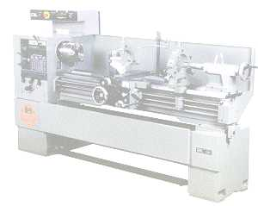
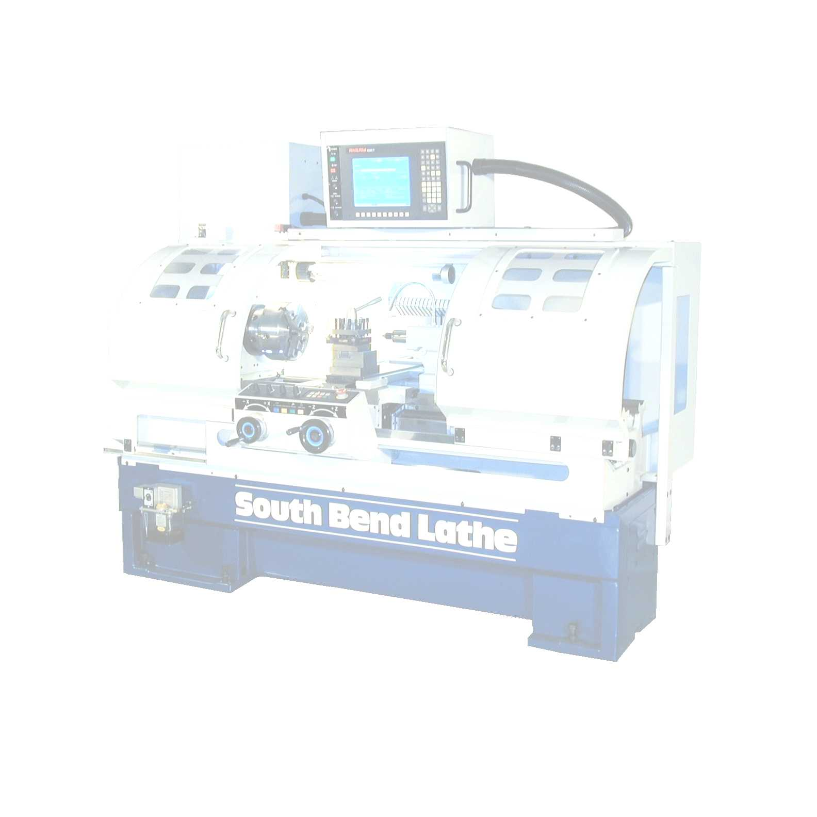
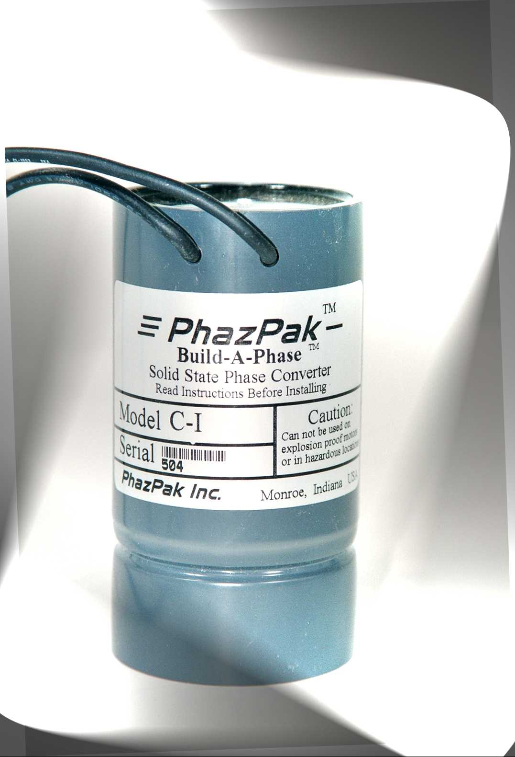
PhazPak has totally simplified the process of building rotary phase converters.
No longer is it necessary to machine or shave motor armatures to aid in the start up of your rotary converter. PhazPak Build-A Phase “I” Model Solid State Phase Converters are designed to start your rotary converter motor quickly and efficiently. PhazPak “I” Model converters are 100% solid state, no relay chattering, no contacts to burn, no regenerative effects on shut-off. PhazPak solid state converters are also very small saving room in your enclosures. Simply choose a good used or new three motor, PhazPak Build-A-Phase “I” Model Converter, and motor running capacitors and your well on your way to building your own rotary converter.

.

toBy simply using a new or good used three phase motor in conjunction with a PhazPak I Model converter and motor running capacitors and offer a wider range of applications than standard PhazPak Models. That’s because “R” Models are designed, to be used with, motor running capacitors. Run capacitors can help your motor operate closer to the rated horsepower of the motor. “R” Model converters will work well on most applications excluding motors applications that require 100% of the rated horsepower continuously, or long, or heavy starting loads. For these kind of applications see PhazPak Heavy Duty Rotary type converters.

* Must reduce motor pulley size
Introducing

Solid State Phase Converter

“I” Models
PhazPak has revolutionized electric motor phase conversion
Now it is both practical and cost effective to build
^{Rotary Phase Converters}

Features

Low Cost
Solid State
Sealed
Easy Installation
Automatic
Electronically Protected
Small Size

Ideal Applications

Industrial
Commercial
Residential
Agricultural

Build-A-Phase

TM

Best In Phase Converters
SM

