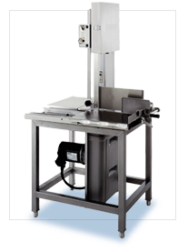
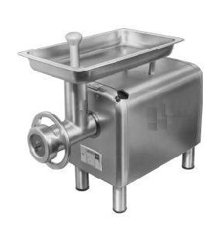
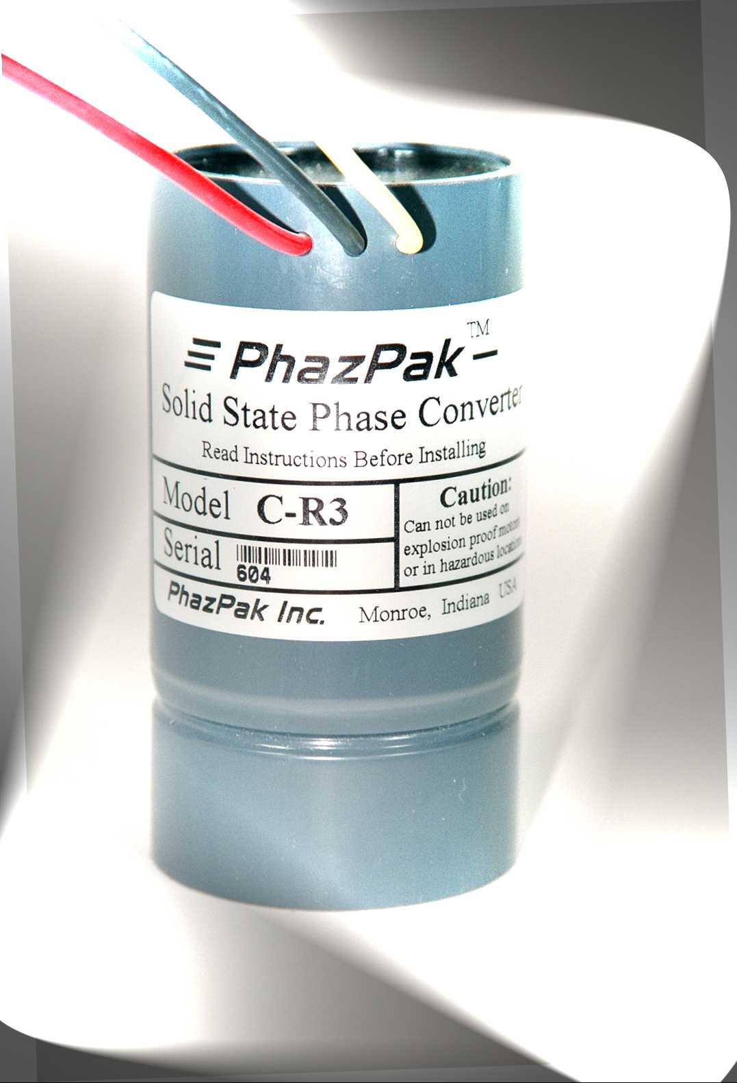
PhazPaks’ New Heavy Duty Solid State “R3” Model Converters will change the way you think about three phase motor conversion. PhazPak static converters are 100% solid state, no relay chattering, no re-generative effects on shut off, and no contacts to burn. There are many applications where single phase motors are just not available or very expensive. Consider using a high service factor three phase motor, and a PhazPak “R3” Heavy Duty Model Phase Converter system. You end up with a very efficient and reliable single phase motor. Now it is both practical and cost effective to convert your three phase motors to single phase. * Must reduce motor pulley size

Best In Phase Converters
Introducing

Heavy Duty Solid State Phase Converter

TM

New “R3” Models
PhazPak has revolutionized electric motor phase conversion
Now it is both practical and cost effective to convert your
three phase motors to single phase

Features

Low Cost
Solid State
Sealed
Easy Installation
Automatic
Reversible
Electronically Protected
Small Size

Ideal Applications

Metal Working
Farm Equipment
Food Processing
Saws
Presses
Wood Working

Conveyors
Air Compressors *
sm.

