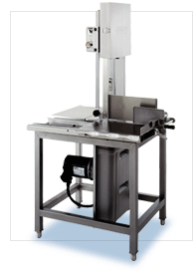
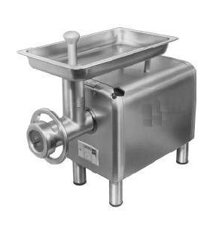
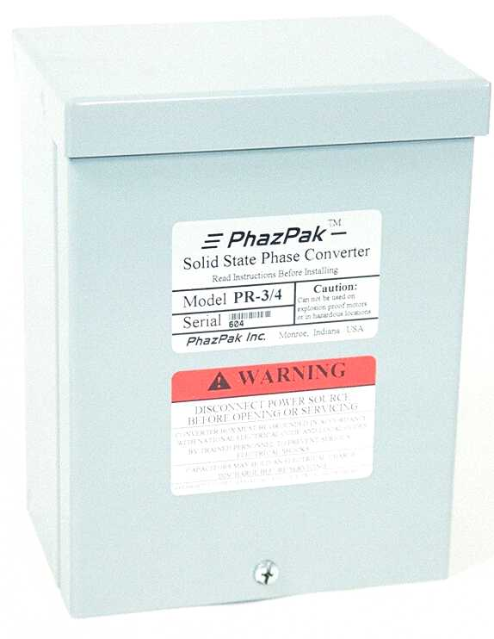
PhazPaks’ New Prepackaged Heavy Duty Solid State “PR” Model Converters opens up a wider range of applications than Standard PhazPak Models. That’s because “R3” Models are designed for use with motor running capacitors. Run capacitors can help your motor operate closer to the rated horsepower of the motor. PhazPak static converters are 100% solid state, no chattering, and no re-generative effects on shut off, no contacts to burn. PhazPaks’ New “R3” Models also provide significantly more starting torque than Standard PhazPak Models. Simply compare feature to feature with any other make static converter and your see why PhazPak Phase Converters are your clear choice.
* Must reduce motor pulley size

Introducing

Heavy Duty Solid State Phase Converter

TM

New “PR” Models
PhazPak has revolutionized electric motor phase conversion
Now it is both practical and cost effective to convert your
Three phase motors to single phase

Features

Ideal Applications

Metal Working
Farm Equipment
Food Processing
Saws
Presses
Wood Working

Conveyors
Air Compressors *

Low Cost
Solid State
Sealed
Easy Installation
Automatic
Reversible

Electronically Protected
Small Size

Best In Phase Converters
SM

